**Lab no 4**

|  |  |
| --- | --- |
| Topic | To familiar with OLTP system reporting |
| Objectives | * To learn report generation in OLTP systems |

Customer Table

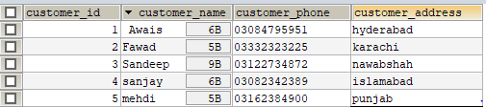

Expenditure

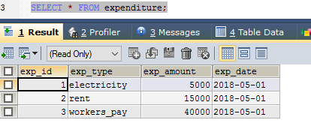

Product Table

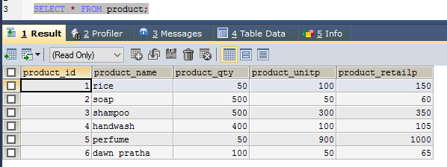

Order Table

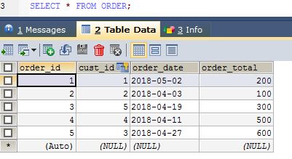

**Stored procedure contains following queries:**

1. **Total sales in a month (Use only order table).**
2. **Profit/loss in a month (Use product (to account for purchasing costs), expenditure as well as order tables).**
3. **Highest selling product of the month (By highest sold quantity)**
4. **Lowest selling product of the month (By lowest sold quantity)**

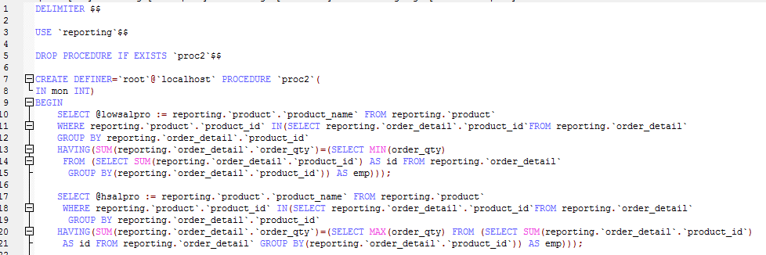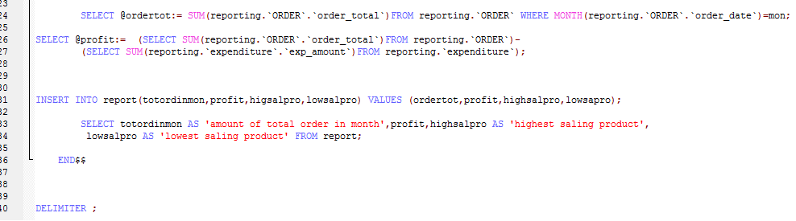

Call



Result

